 | MH Capital Growth AMC  Minimum Disclosure Document • Data as at 31 August 2026

KEY FACTS  RISK INDICATOR  These investments typically exhibit more volatility given their higher exposure to equities, which may result in capital losses. Expected potential long-term returns could be higher than other risk profiles – conversely potential losses could also be higher.  REGIONAL ALLOCATION | FUND OBJECTIVE & STRATEGY  At MH Capital we identify and capitalize on unique investment opportunities. Through a disciplined approach we provide our investors access to listed companies not accessible through other investment products.  WHO SHOULD INVEST  This investment is well-suited for long-term investors seeking the potential for enhanced capital growth. Due to the note’s differentiated and targeted strategy, it is best viewed as a complementary addition to an investor’s existing portfolio. Investors should have the capacity to tolerate higher levels of capital volatility associated with this type of investment.  PERFORMANCE  ¹ Benchmark: Inflation + 8% p.a. Returns are cumulative, net of fees, in ZAR since inception (7 March 2025). Periods of one year or less are not annualised.  TOP 5 HOLDINGS  Top 5 holdings represent 50.6% of the portfolio.  PERFORMANCE HIGHLIGHTS
  Portfolio Manager | Marius Hugo
  Launch Date | 07 March 2025
  Structure | Standard Bank AMC
  Benchmark | Inflation + 8%
  Note Price | R1 312.82
  Notes in Issue | 22 852
  Fund Size (AUM) | R30.00 million
  Denomination | ZAR
  Management Fee | 1.25% p.a. (excl. VAT)
  ISIN | ZAE000343836
  Alpha Code | AMC018
  LOW | LOW– | MED | MED– | HIGH
   | ■ South Africa 85%  ■ United States 15%  US exposure held via Berkshire Hathaway.
   | 3 Months | 6 Months | 1 Year | Since Inception
  Fund | -1.08% | -1.45% | 9.88% | 31.28%
  Benchmark¹ | 3.00% | 5.92% | 11.82% | 17.59%
  Holding | % Portfolio
  Berkshire Hathaway | 15.0%
  Reinet Investments | 9.6%
  Naspers | 9.6%
  Stadio | 9.1%
  Premier Group | 7.4%
  +31.28%  Fund since inception | +17.59%  Benchmark (CPI + 8%) | R1 312.82  Note price

CUMULATIVE PERFORMANCE SINCE INCEPTION

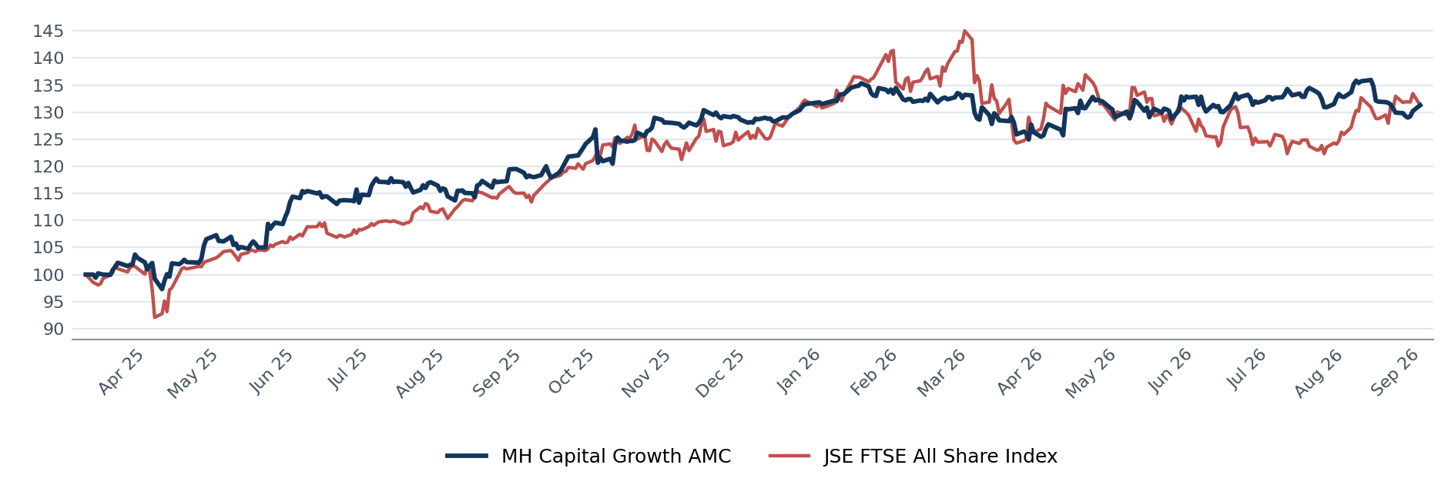
MH Capital Growth AMC vs JSE FTSE All Share Index, indexed to 100 at inception (7 March 2025).

Issuer / Manager: MH Capital · FSP No. 51988 Structure: Standard Bank AMC ISIN: ZAE000343836 Alpha Code: AMC018
An Actively Managed Certificate (AMC) is a listed structured product; its value is linked to a reference portfolio actively managed by the investment manager. This Minimum Disclosure Document is for information purposes only and does not constitute financial advice or an offer to invest. Investors should seek independent advice suited to their circumstances. Collective and structured investments are generally medium- to long-term investments. Past performance is not necessarily a guide to future performance, and the value of investments may fall as well as rise and is not guaranteed. Performance is calculated on a NAV-to-NAV basis, net of fees, in ZAR, with income reinvested. Prices are calculated and published daily.

